DATA CLEANING AND PREPARATION:
- REMOVE DUPLICATES
- FONT STYLE
- CONDITIONAL FORMATTING
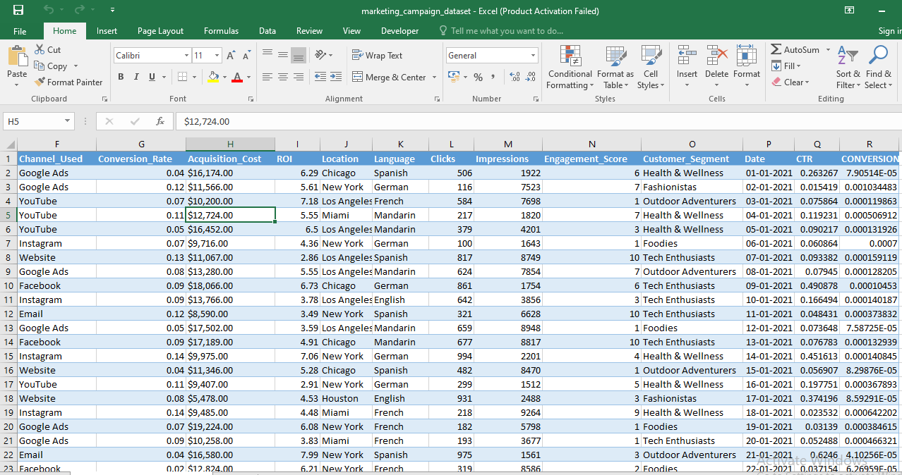

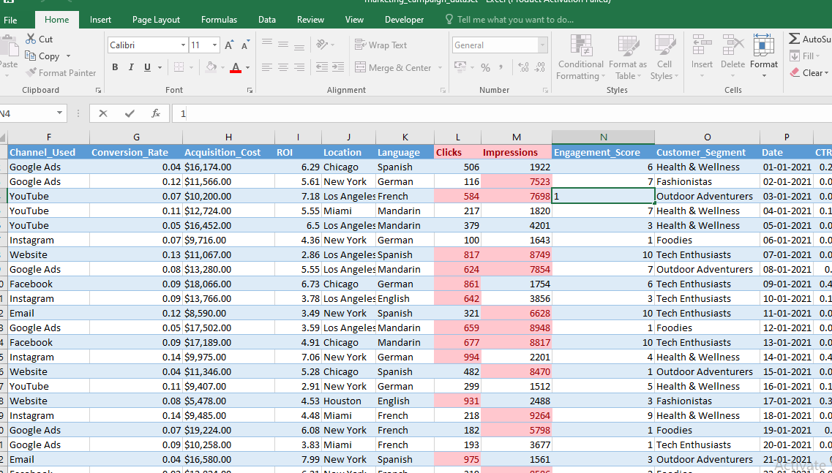

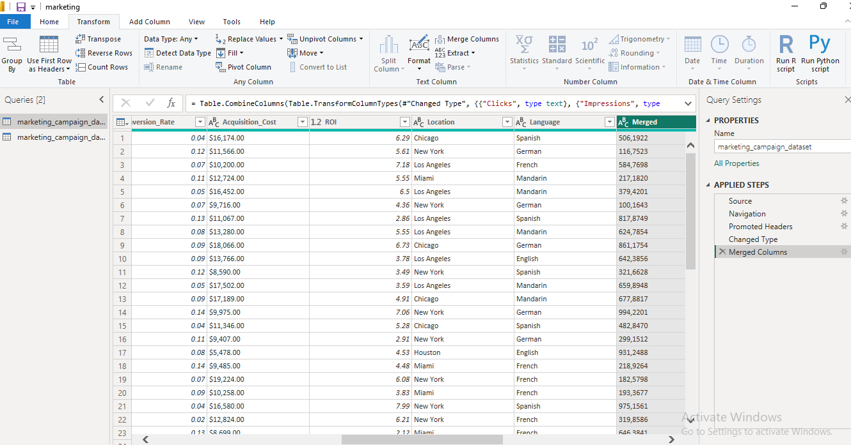

DASHBOARD CHARTS

1. KPI CARDS (TOP ROW)

Visual: Card
Use for big numbers
Cards to add:
- Total Impressions
- Total Clicks
- CTR (%)
- Conversion Rate (%)
- Total Spend
- Average ROI

2. CHANNEL PERFORMANCE

Visual: Clustered Column Chart
Best for comparison
Fields:
- Axis: Channel Category
- Values: Total Conversions
- Tooltips: CTR (%), CPA

Visual: Bar Chart
Fields:
- Axis: Channel Category
- Values: Total Spend
Compare budget vs results

3.CTR & CONVERSION ANALYSIS

Visual: Line Chart
Fields:
- X-Axis: Date
- Y-Axis: CTR (%) it Shows trend over time

Visual: Combo Chart (Line + Column)
Fields:
- X-Axis: Date
- Column Values: Total Clicks
- Line Values: Conversion Rate (%)
- Clicks vs conversions relationship

4.CUSTOMER & AUDIENCE INSIGHTS

Visual: Donut Chart
Fields:
- Legend: Customer_Segment
- Values: Total Conversions
- Understand customer mix

Visual: Bar Chart
Fields:
- Axis: Target_Audience
- Values: CTR (%)
- Best audience groups

5.LANGUAGE PERFORMANCE

Visual: Column Chart
Fields:
- Axis: Language
- Values: Conversion Rate (%)
- Which language works best

6.LOCATION ANALYSIS

Visual: Map
Fields:
- Location: Location
- Size: Total Conversions
- Tooltips: ROI, CTR
- Geographic performance

7.ENGAGEMENT ANALYSIS

Visual: Bar Chart
Fields:
- Axis: Channel Category
- Values: Avg Engagement Score
- Engagement vs channel

8.DETAILED TABLE (BOTTOM)

Visual: Table
Columns to include:
- Company
- Campaign_Type
- Channel Category
- Language
- CTR (%)
- Conversion Rate (%)
- CPA
- ROI
- Performance Label
- Drill-down analysis

9.SLICERS (VERY IMPORTANT)

Visual: Slicer
Add these:
- Channel Category
- Language
- Date
- Location
- Customer_Segment
- Interactivity

10.SUMMARY TABLE
Purpose | Chart
Summary | Card
Comparison | Column / Bar
Trend | Line
Relationship | Combo
Distribution | Donut
Geography | Map
Details | Table

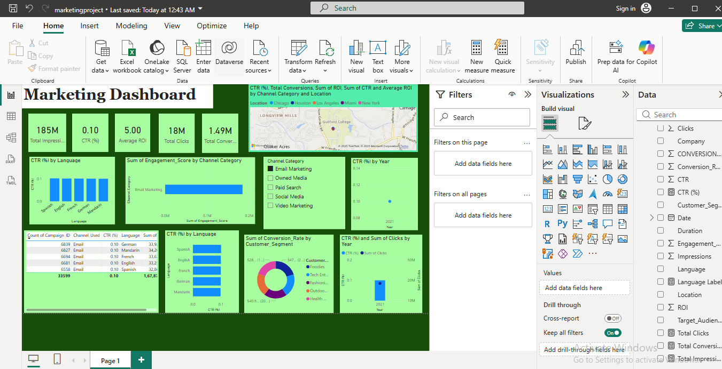

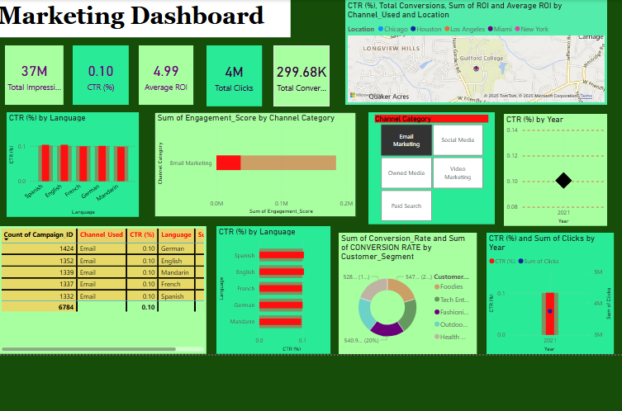

11.DAX FORMULAS:
1.CTR (%) =
DIVIDE (
[Total Clicks],
[Total Impressions],
0
)

2.Channel Category =
SWITCH (
marketing_campaign_dataset[Channel_Used],
"Google Ads", "Paid Search",
"YouTube", "Video Marketing",
"Facebook", "Social Media",
"Instagram", "Social Media",
"Email", "Email Marketing",
"Website", "Owned Media",
"Other"
)

3. Average ROI =
AVERAGE ( marketing_campaign_dataset[ROI] )

4. Language Label =
SWITCH (
SELECTEDVALUE ( marketing_campaign_dataset[Language] ),
"English", "English Campaign",
"Spanish", "Spanish Campaign",
"German", "German Campaign",
"Multiple Languages"
)

5. Total Clicks =
SUM ([Clicks] )
